UNITED STATES
SECURITIES AND EXCHANGE COMMISSION
WASHINGTON, D.C. 20549

FORM 8-K

CURRENT REPORT
Pursuant to Section 13 or 15(d) of the Securities Exchange Act of 1934
Date of Report (Date of earliest event reported): October 12, 2026

FIRST TRACKS BIOTHERAPEUTICS, INC.
(Exact name of Registrant as Specified in Its Charter)

Delaware |  |  | 001-43177 | 39-5003207
(State or Other Jurisdiction  of Incorporation) |  |  | (Commission File Number) | (IRS Employer  Identification No.)
10770 Wateridge Circle, Suite 210
San Diego, California |  |  |  | 92121
(Address of Principal Executive Offices) |  |  |  | (Zip Code)

Registrant’s Telephone Number, Including Area Code: 858 362-6295

N/A
(Former Name or Former Address, if Changed Since Last Report)

Check the appropriate box below if the Form 8-K filing is intended to simultaneously satisfy the filing obligation of the registrant under any of the following provisions:
☐Written communications pursuant to Rule 425 under the Securities Act (17 CFR 230.425)
☐Soliciting material pursuant to Rule 14a-12 under the Exchange Act (17 CFR 240.14a-12)
☐Pre-commencement communications pursuant to Rule 14d-2(b) under the Exchange Act (17 CFR 240.14d-2(b))
☐Pre-commencement communications pursuant to Rule 13e-4(c) under the Exchange Act (17 CFR 240.13e-4(c))
Securities registered pursuant to Section 12(b) of the Act:
Title of each class |  | Trading  Symbol(s) |  | Name of each exchange on which registered
Common stock, par value $0.001 per share |  | TRAX |  | The Nasdaq Stock Market LLC
Indicate by check mark whether the registrant is an emerging growth company as defined in Rule 405 of the Securities Act of 1933 (§ 230.405 of this chapter) or Rule 12b-2 of the Securities Exchange Act of 1934 (§ 240.12b-2 of this chapter).
Emerging growth company ☒
If an emerging growth company, indicate by check mark if the registrant has elected not to use the extended transition period for complying with any new or revised financial accounting standards provided pursuant to Section 13(a) of the Exchange Act. ☐

Item 7.01 Regulation FD Disclosure.
On October 12, 2026, First Tracks Biotherapeutics, Inc. (the “Company”) updated its corporate investor presentation, a full copy of which is attached hereto as Exhibit 99.1.
The information in this Item 7.01, including Exhibit 99.1, shall not be deemed “filed” for purposes of Section 18 of the Securities Exchange Act of 1934, as amended (the “Exchange Act”), or otherwise subject to the liabilities of that section, nor shall it be deemed incorporated by reference into any other filing under the Exchange Act or the Securities Act of 1933, as amended, except as expressly set forth by specific reference in such a filing.

Item 8.01 Other Events.
On October 12 2026, the Company issued a press release announcing positive topline data from the first Phase 1b cohort of ANB033 in Celiac Disease. A copy of the press release is filed herewith as Exhibit 99.2.

Item 9.01 Financial Statements and Exhibits.
(d) Exhibits
Exhibit No. | Exhibit Title or Description
99.1 | First Tracks Corporate Presentation October 2026.
99.2 | First Tracks Biotherapeutics, Inc. Press Release, dated October 12, 2026.
104 | Cover Page Interactive Data File (the cover page XBRL tags are embedded within the inline XBRL document).

SIGNATURES
Pursuant to the requirements of the Securities Exchange Act of 1934, as amended, the registrant has duly caused this report to be signed on its behalf by the undersigned hereunto duly authorized.
 |  |  | FIRST TRACKS BIOTHERAPEUTICS, INC.
Date: | October 13, 2026 | By: | /s/ Ajim Tamboli
Name: Ajim Tamboli
Title: Chief Financial Officer

Exhibit 99.1
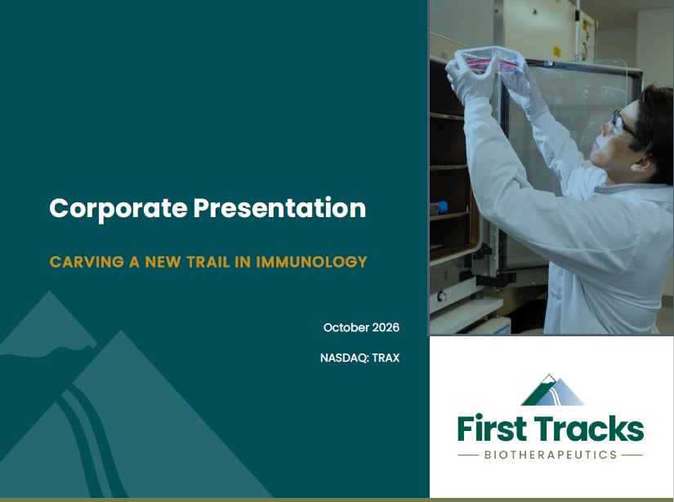

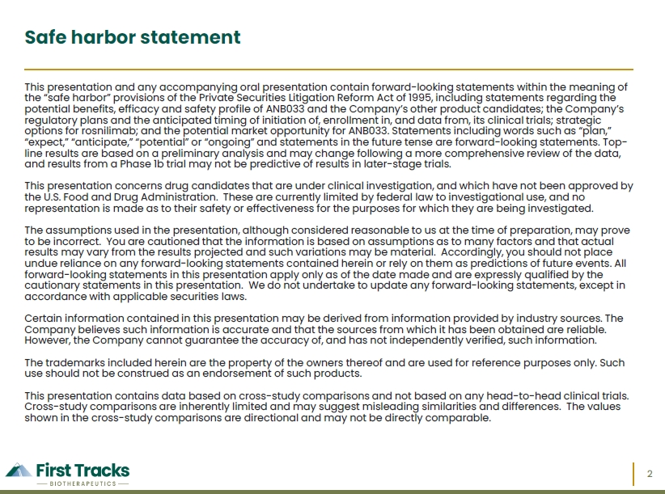

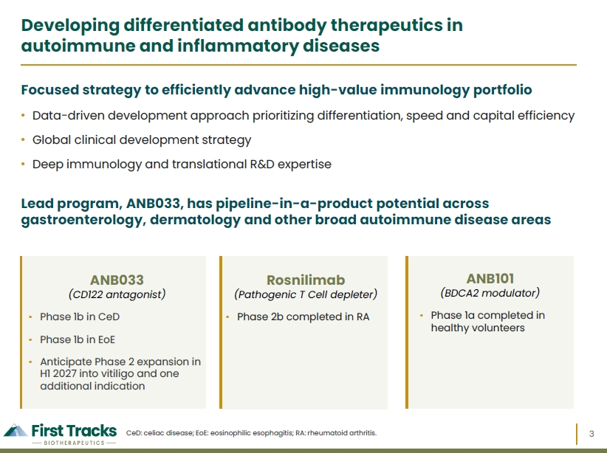

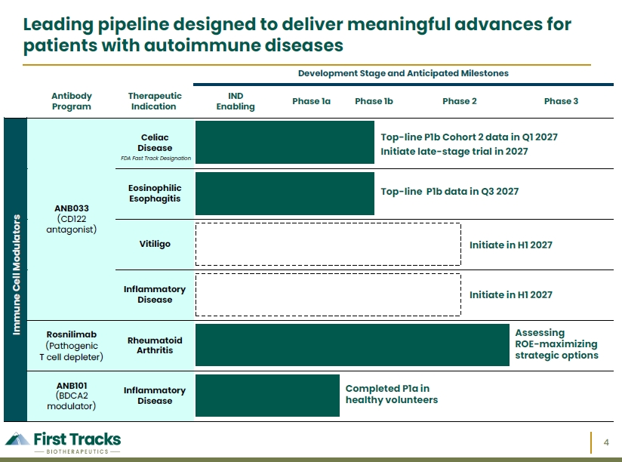

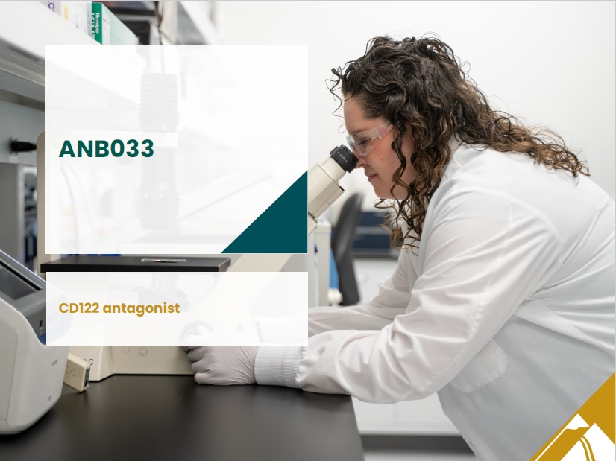

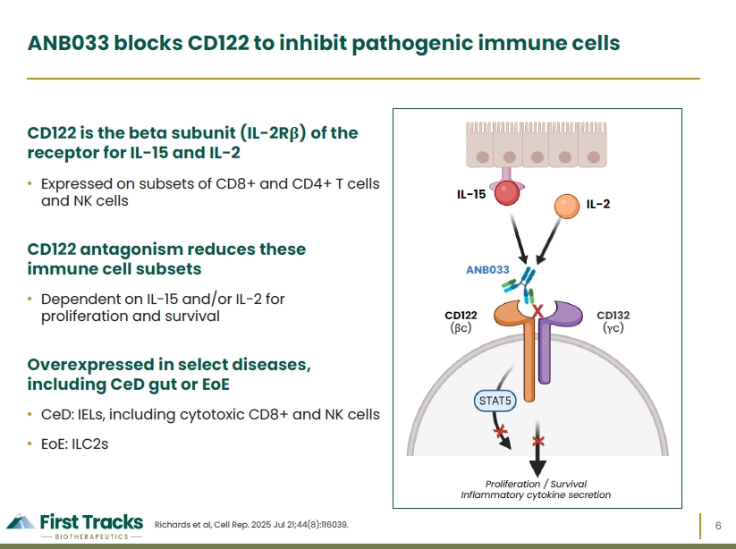

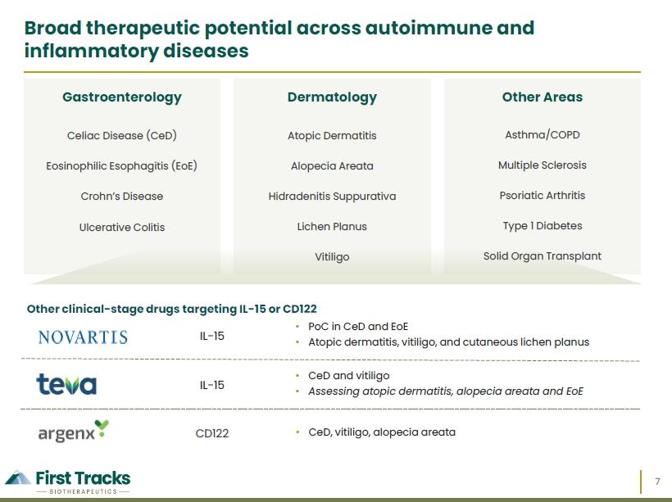

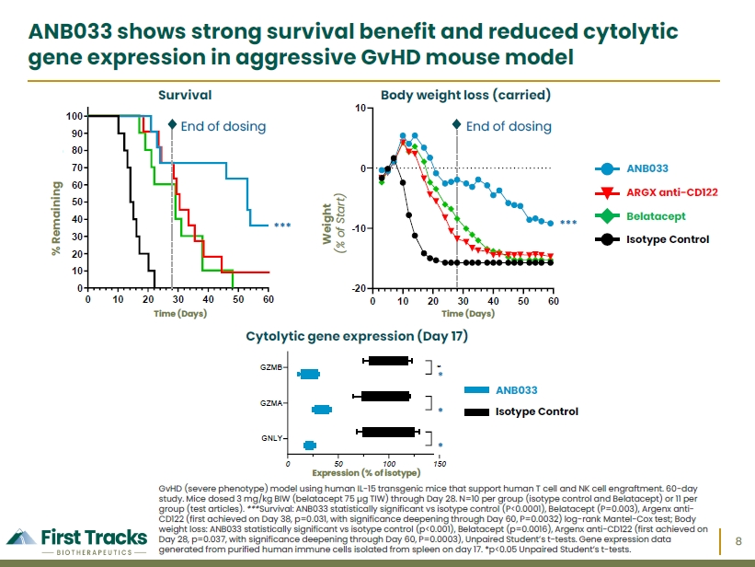

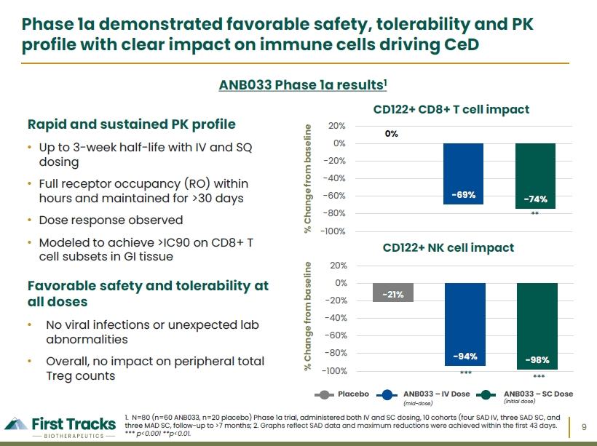

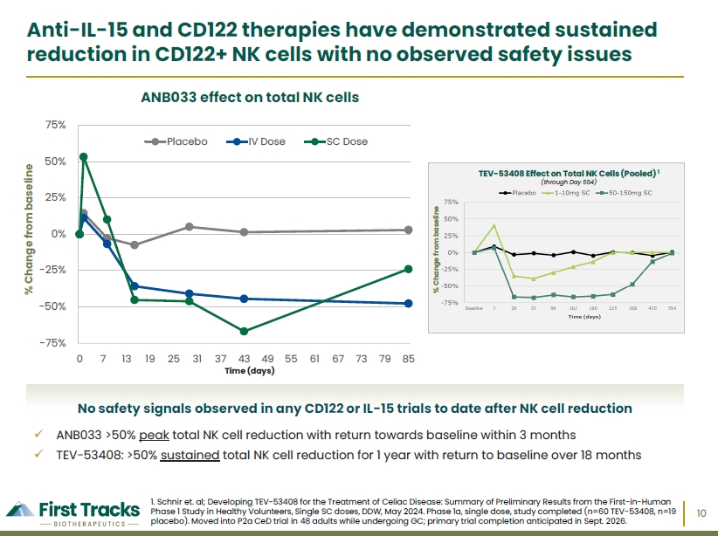

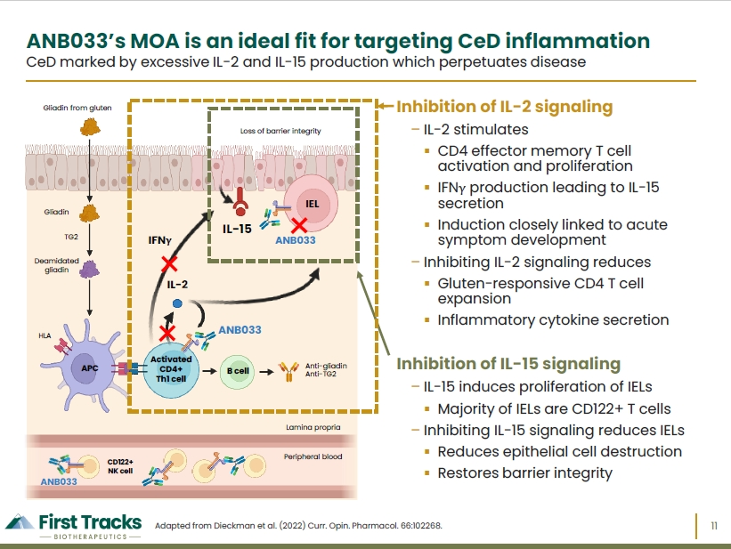

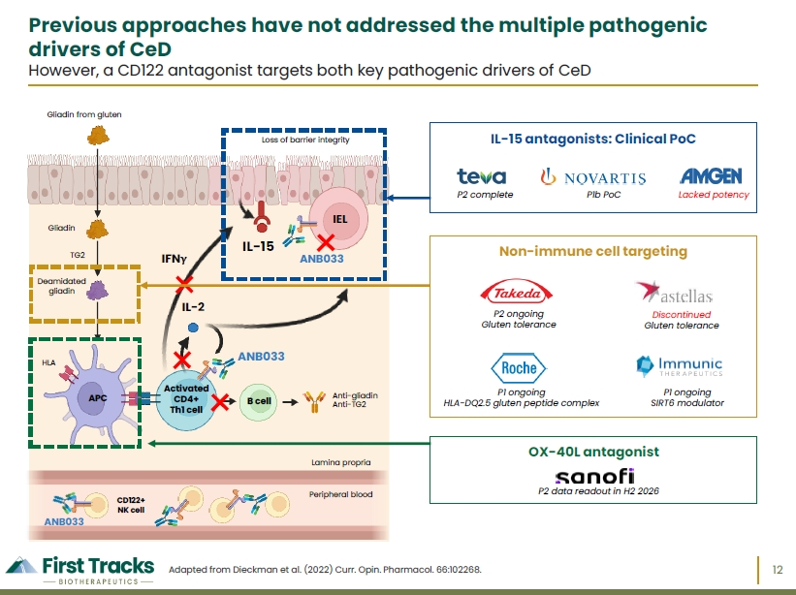

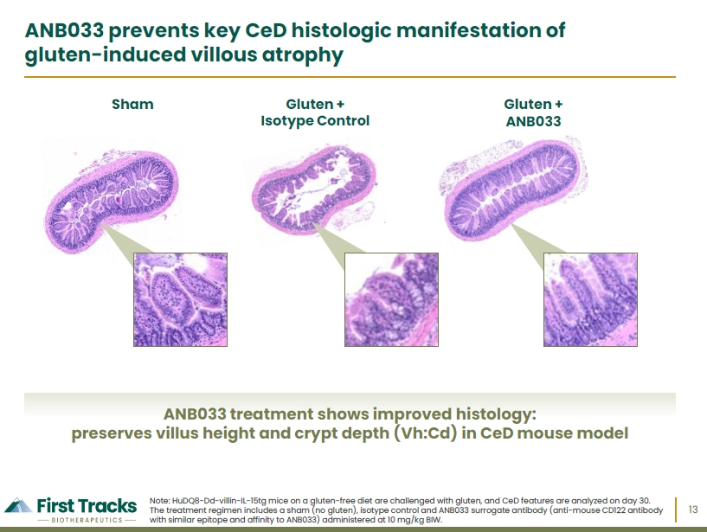

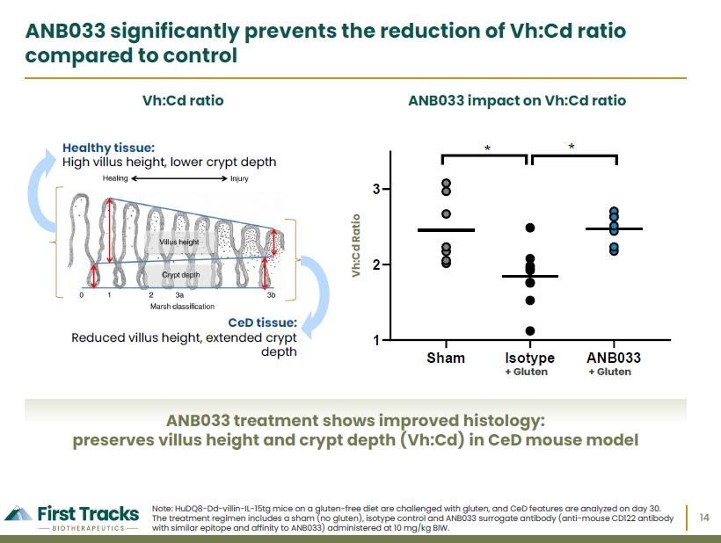

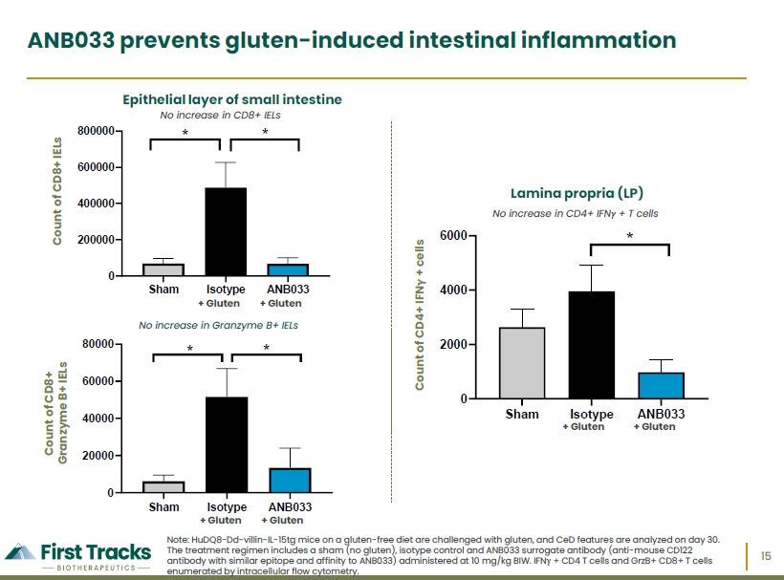

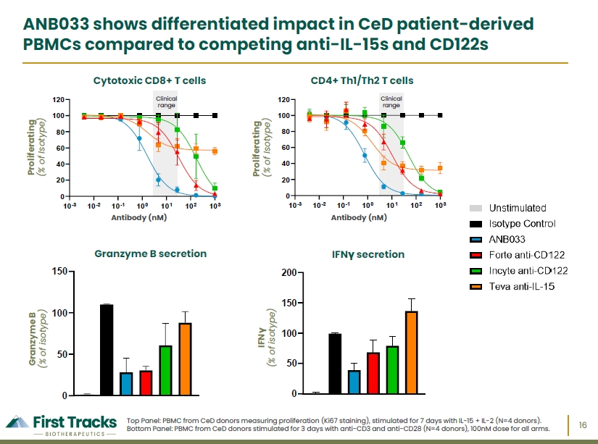

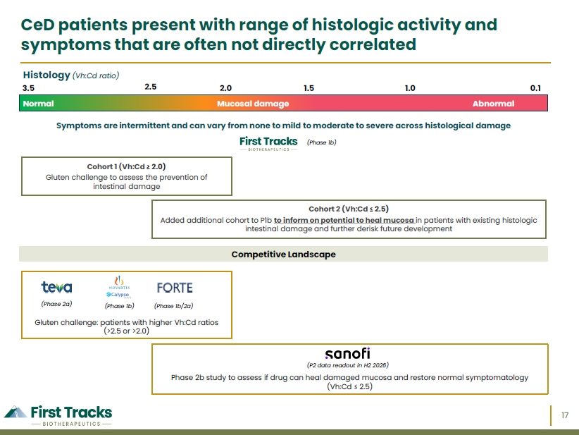

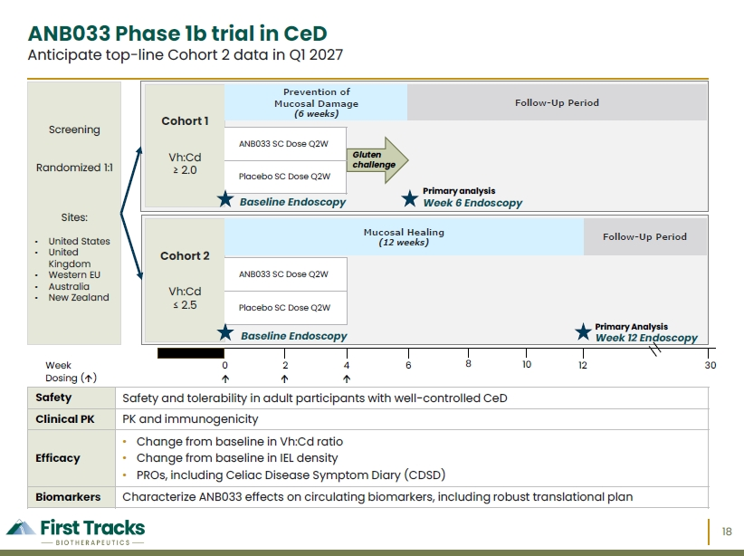

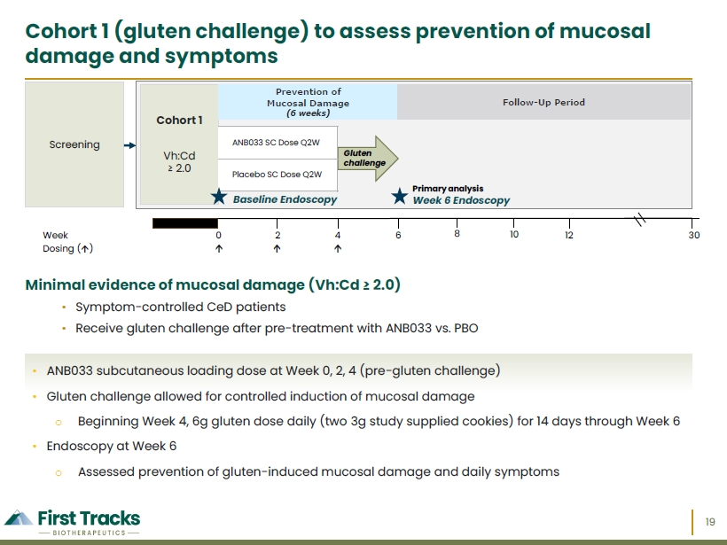

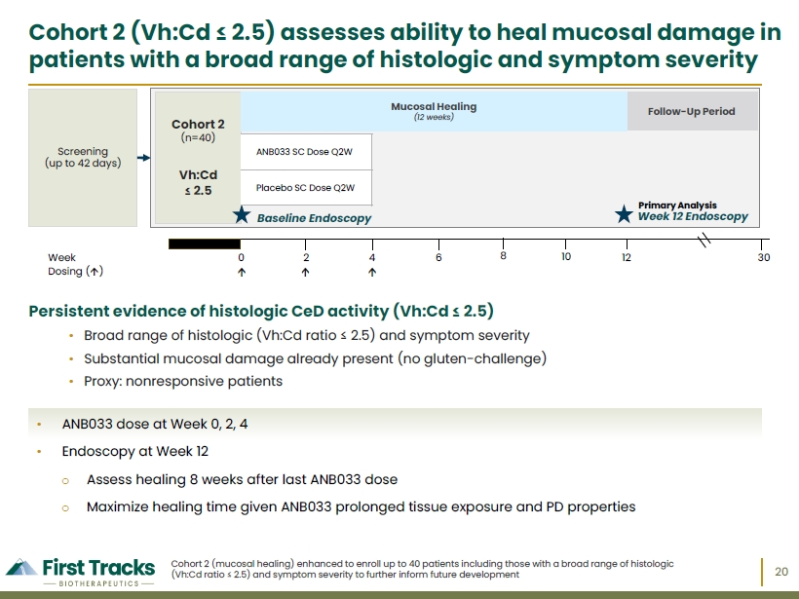

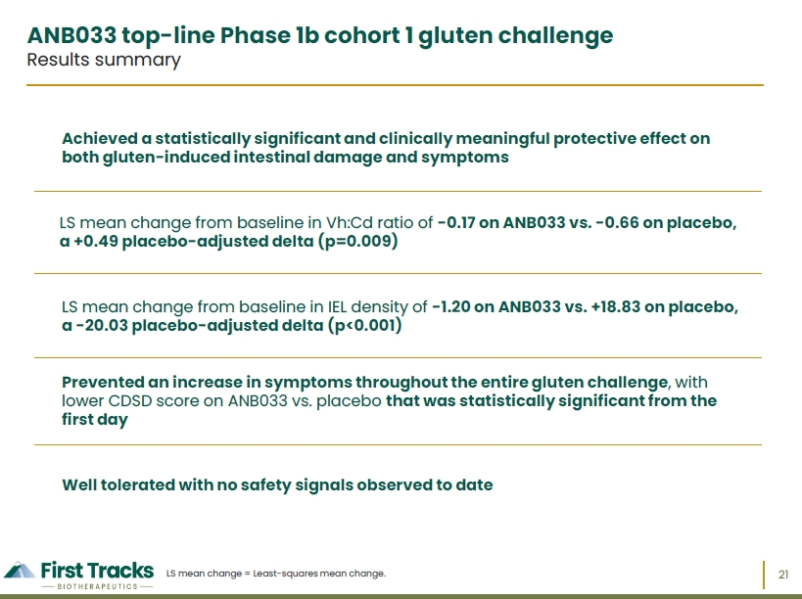

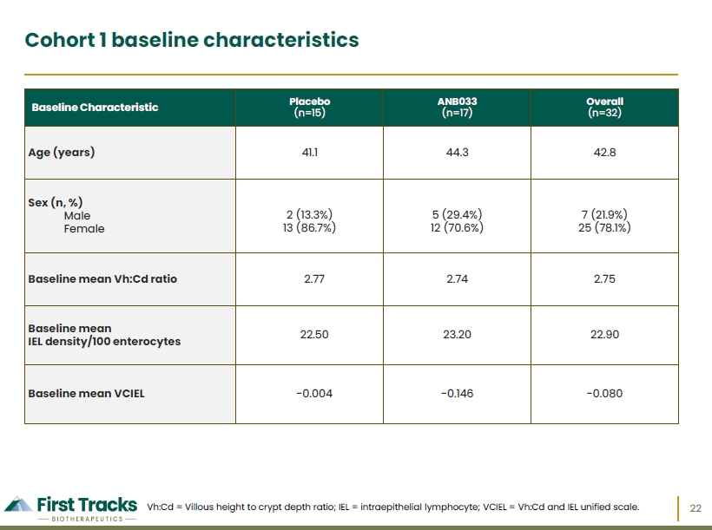

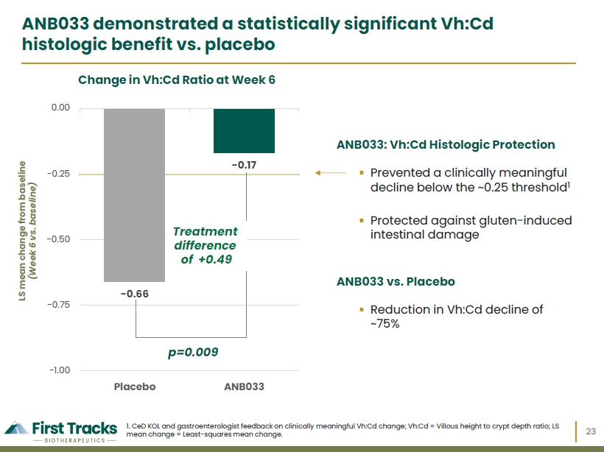

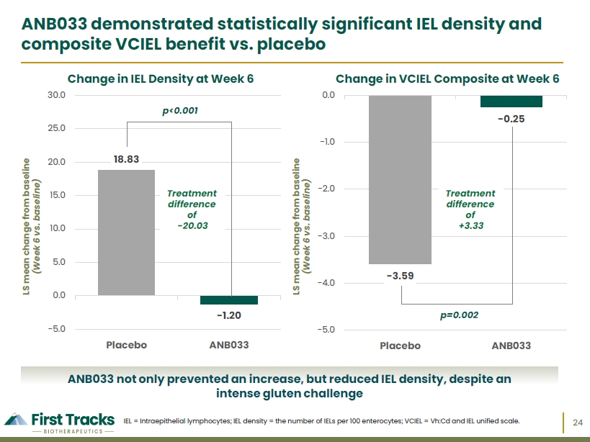

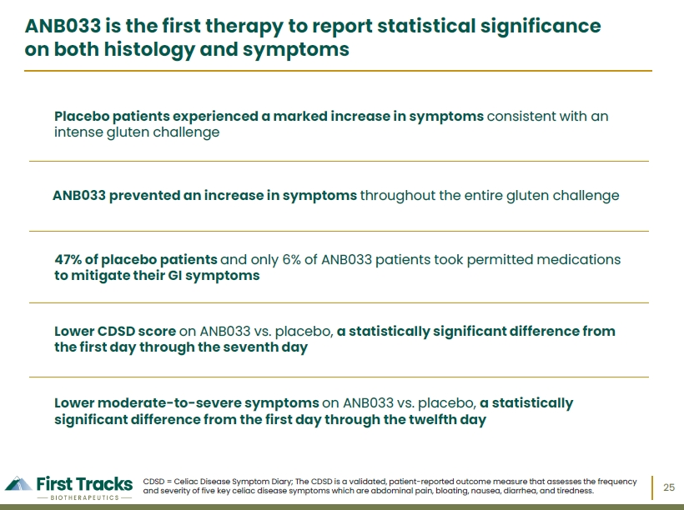

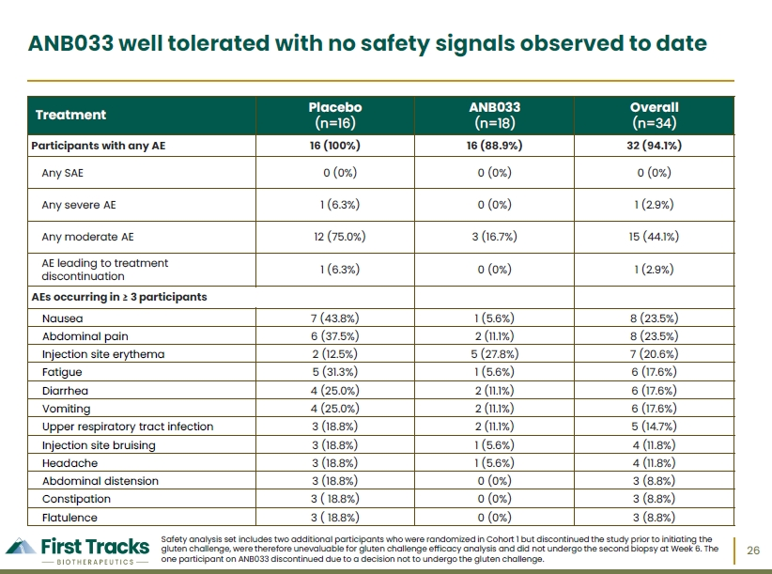

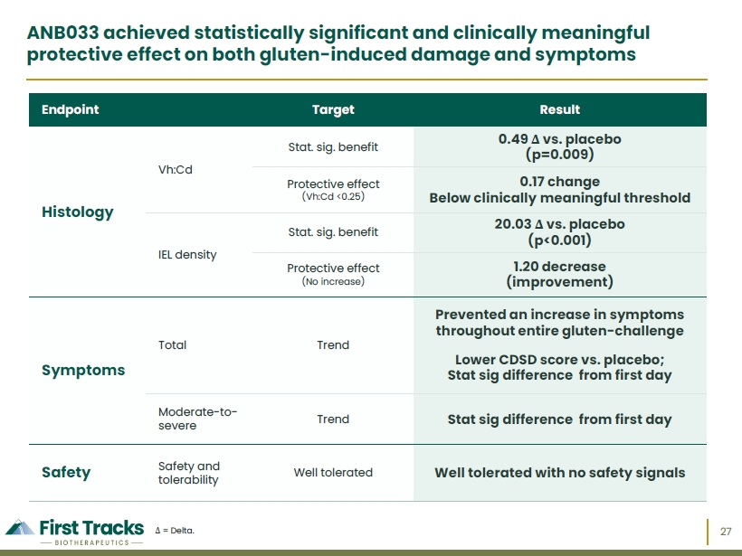

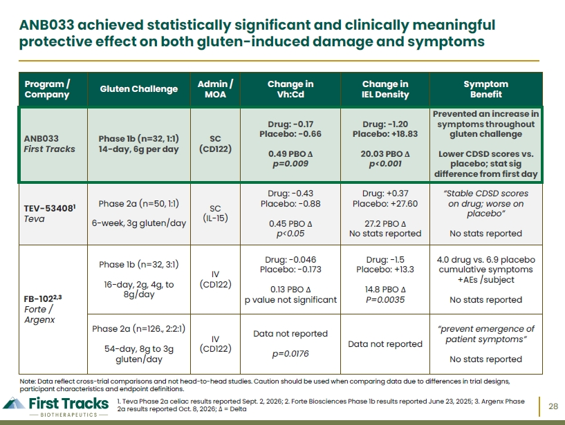

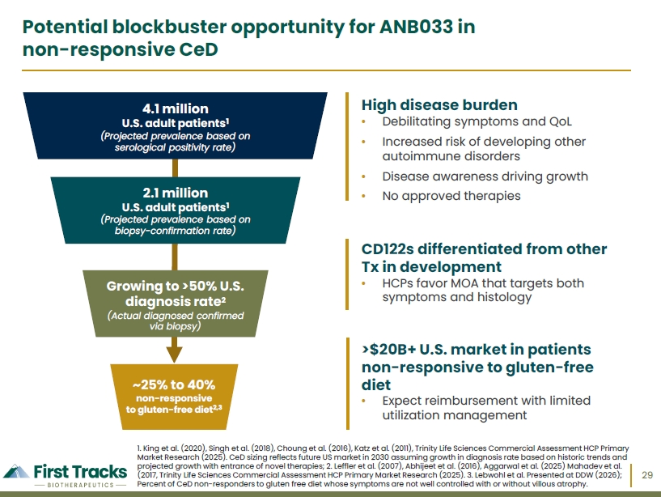

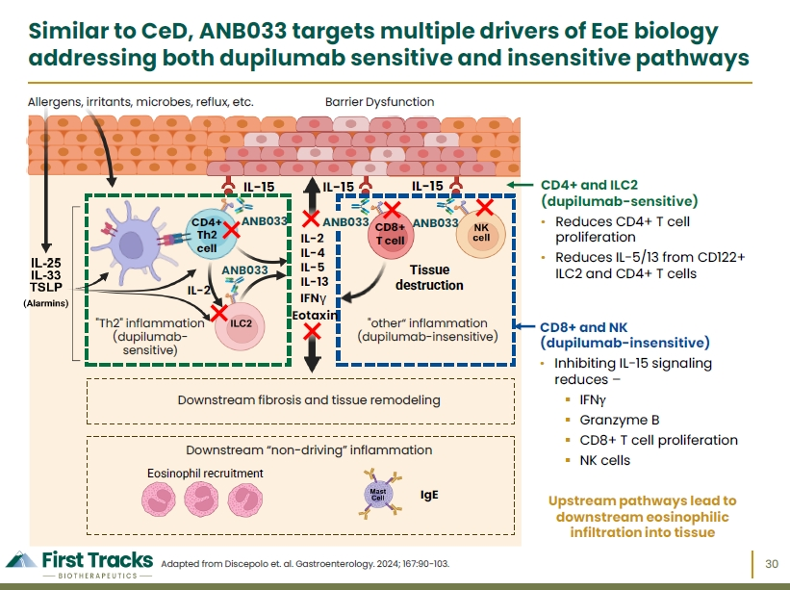

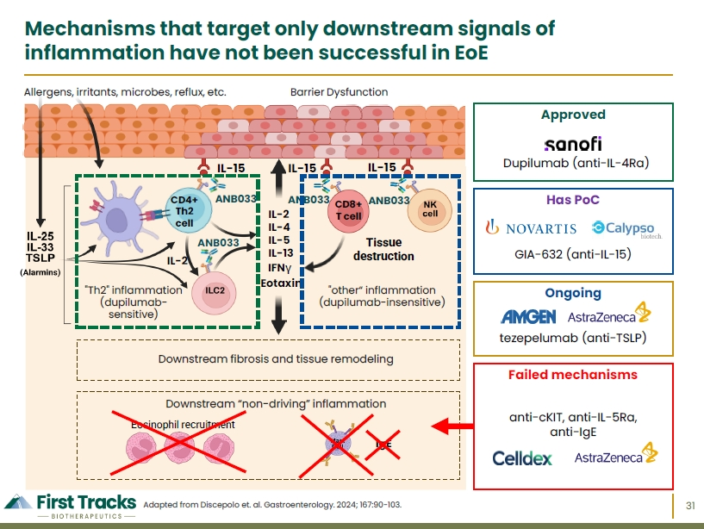

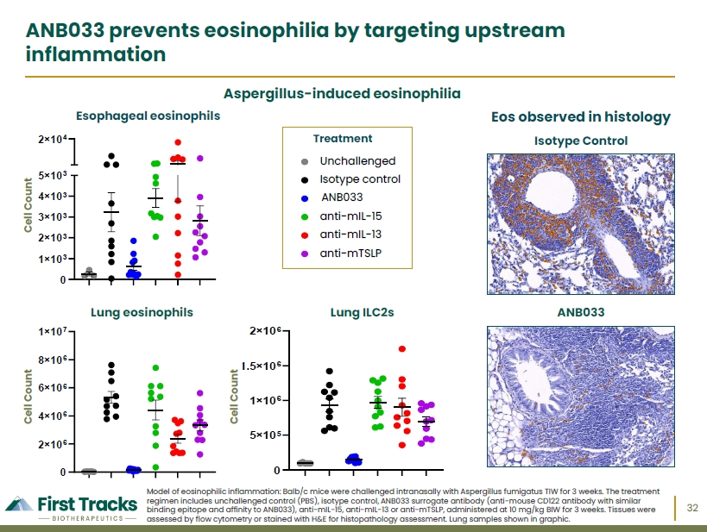

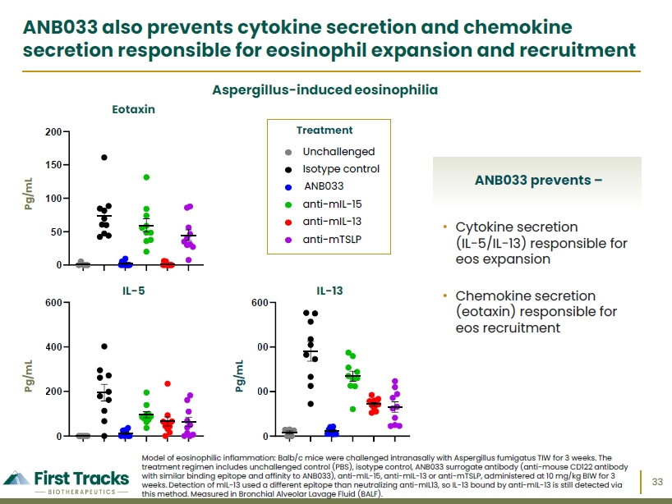

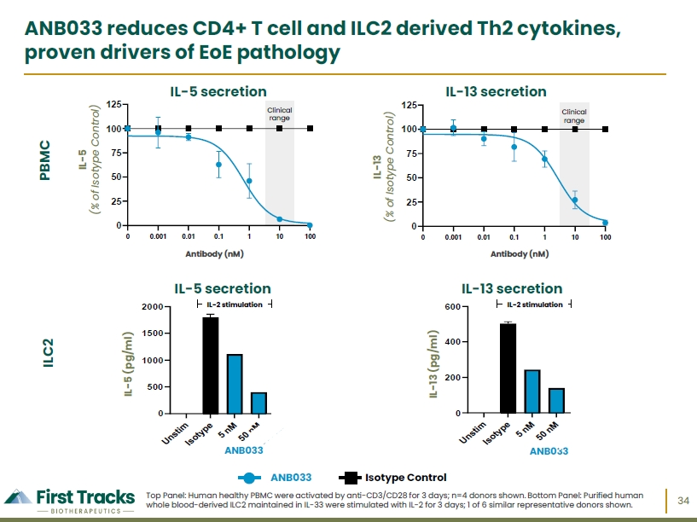

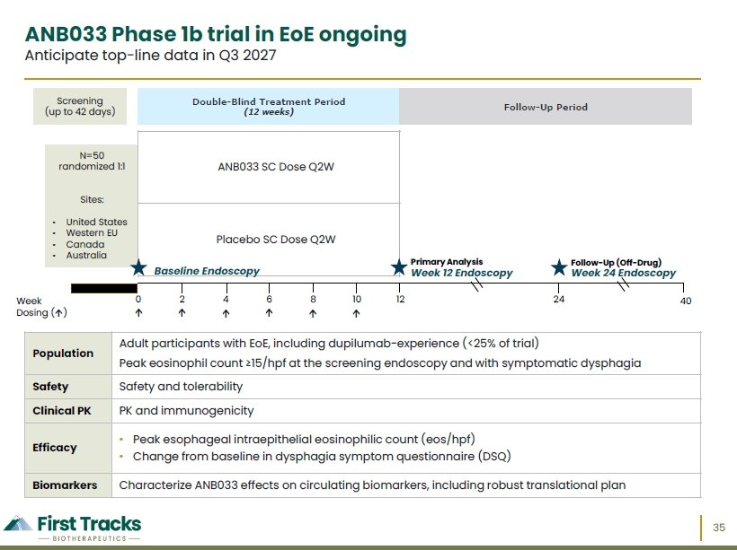

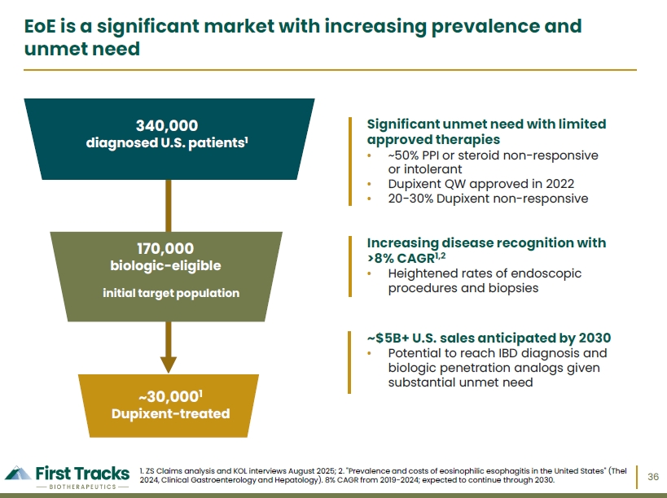

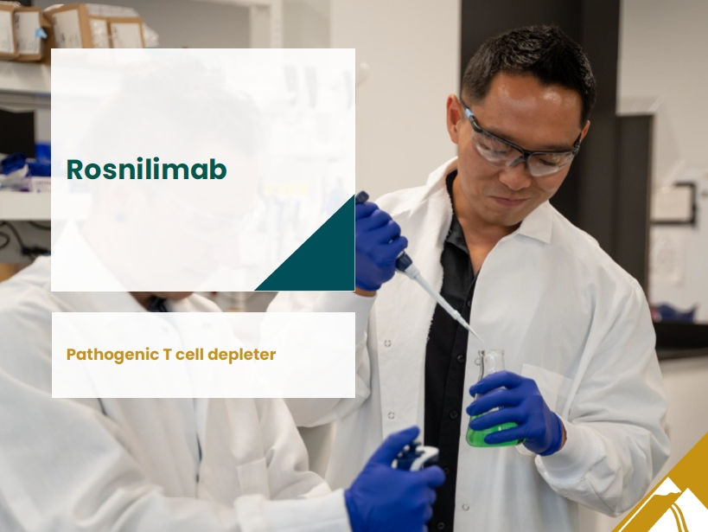

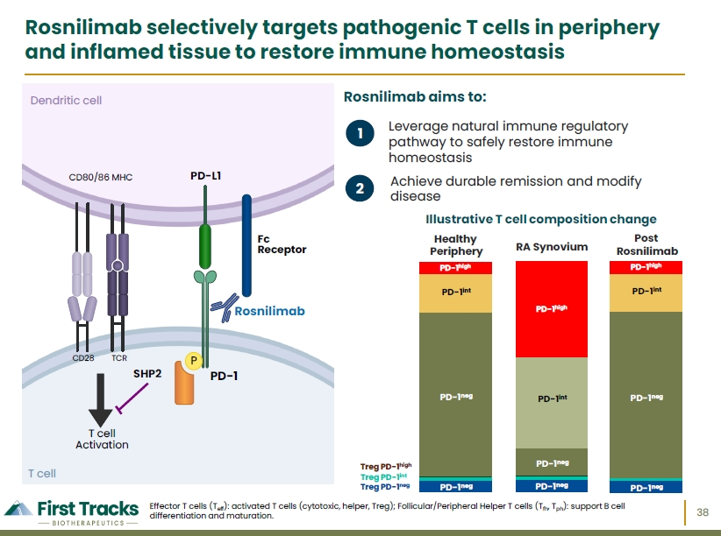

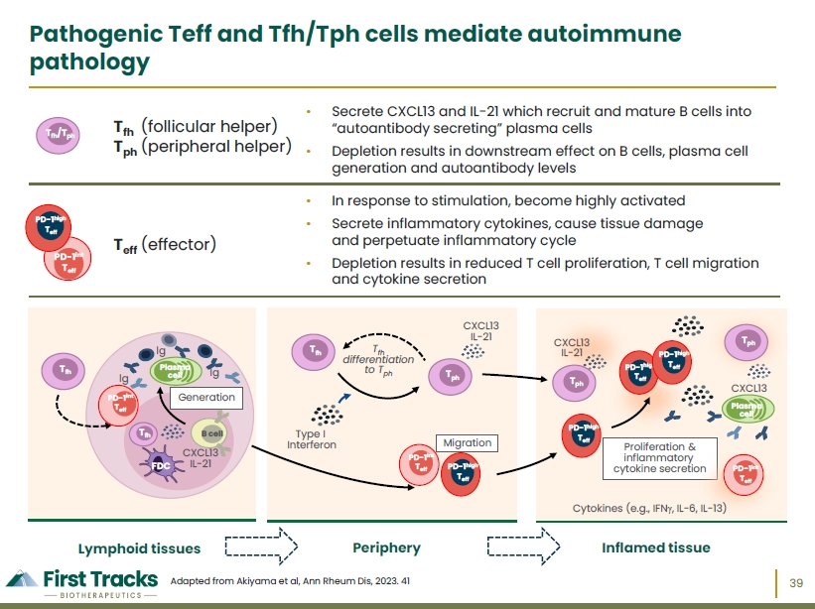

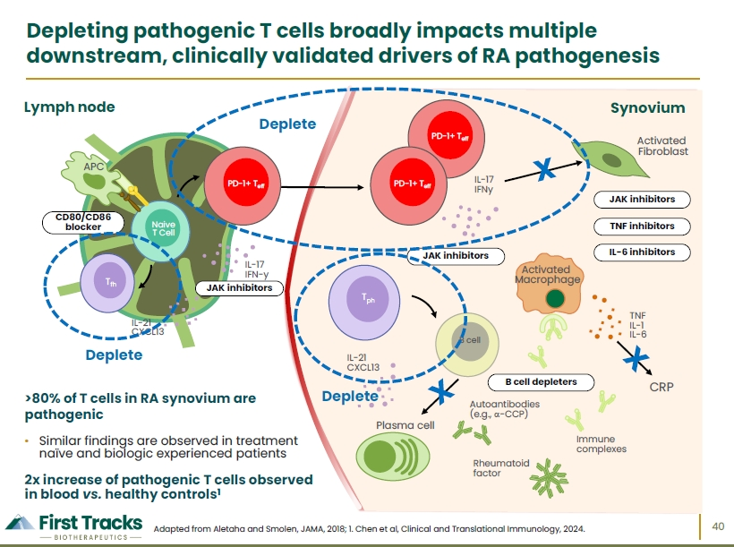

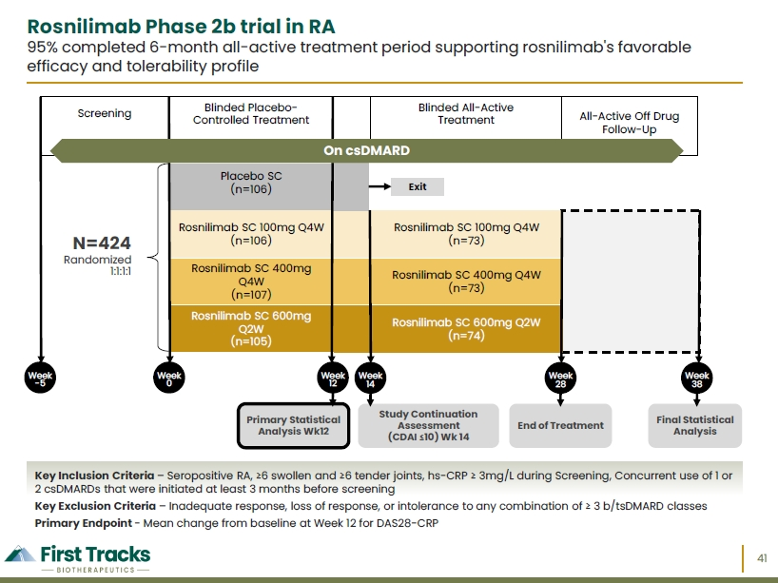

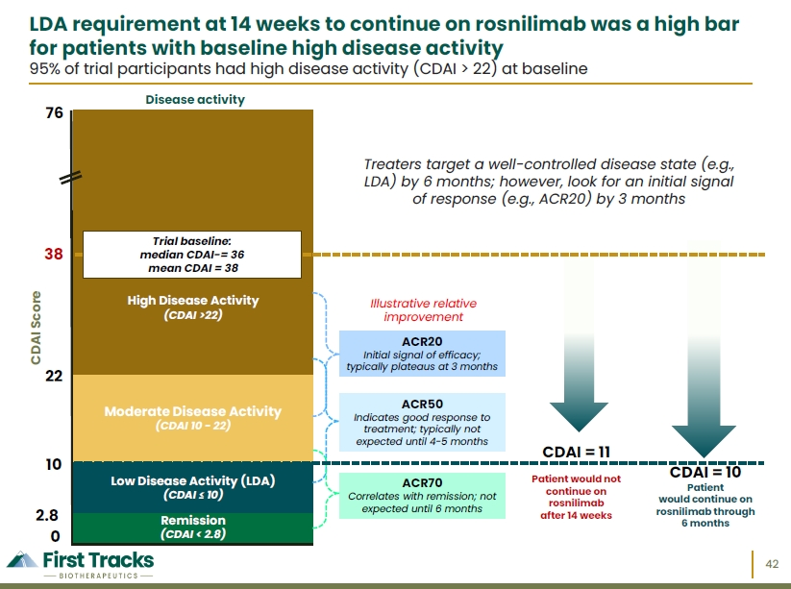

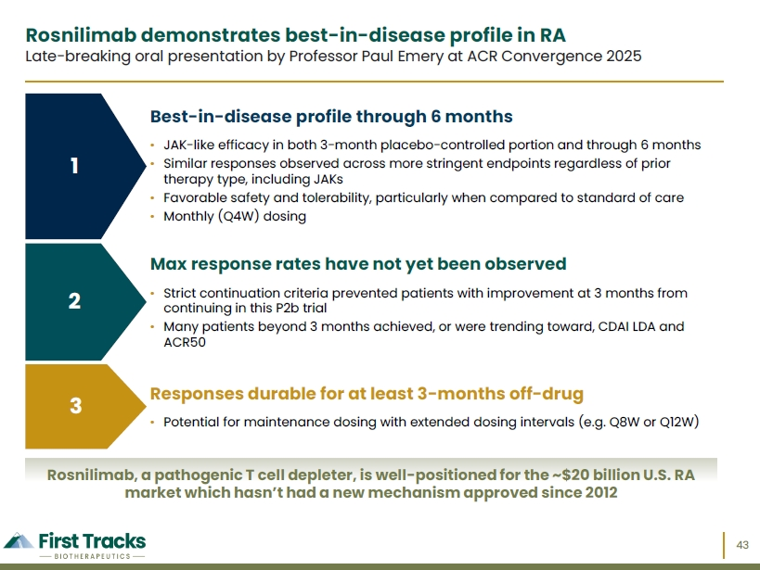

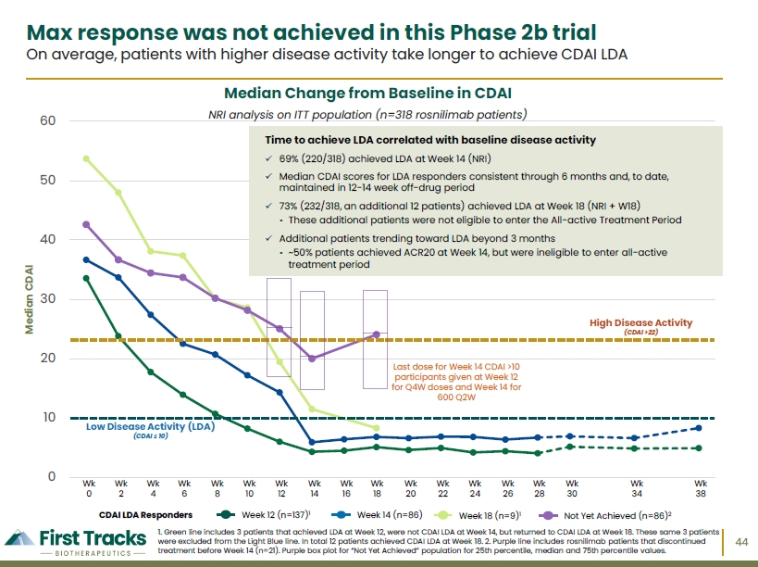

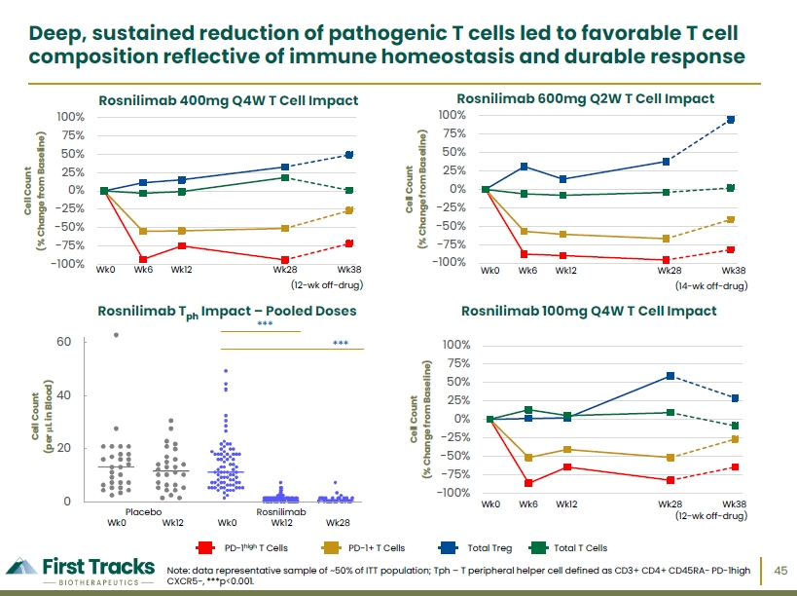

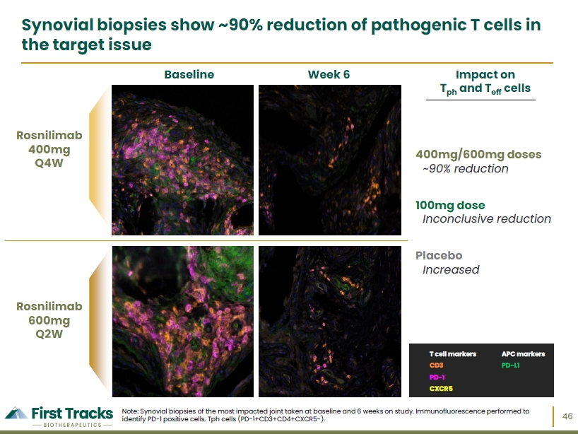

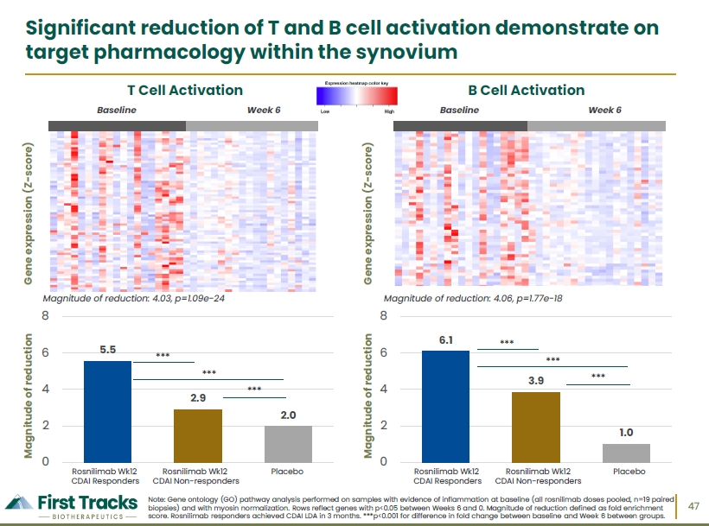

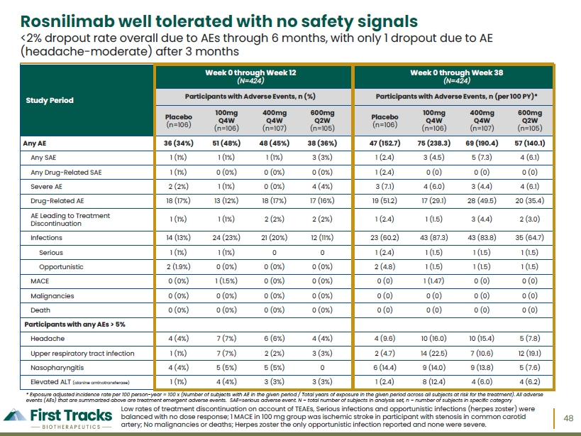

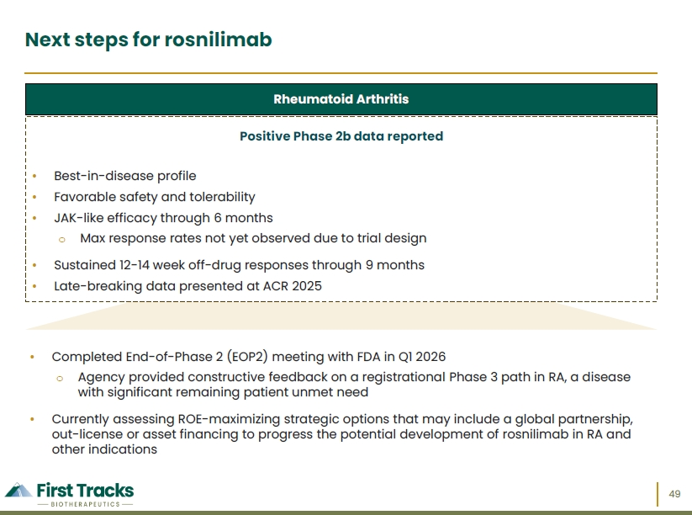



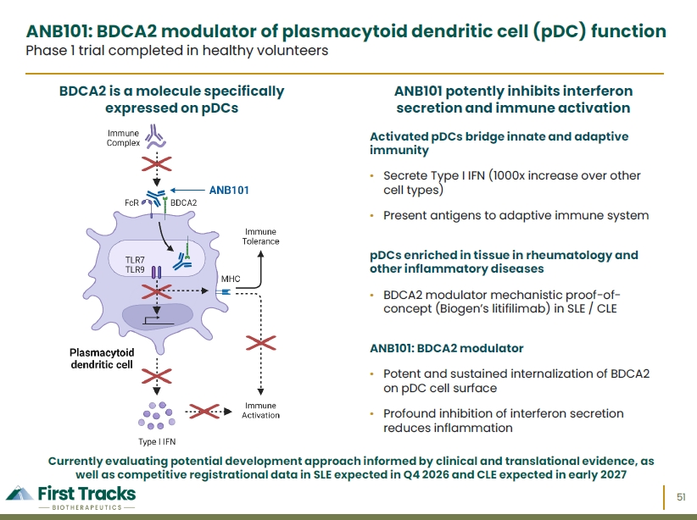

Exhibit 99.2

First Tracks Biotherapeutics Announces Positive Top-Line Results for ANB033 in
Gluten-Challenge Study in Celiac Disease

•
ANB033 achieved a statistically significant and clinically meaningful protective effect on both gluten-induced intestinal damage and symptoms
•
LS mean change from baseline in Vh:Cd ratio of -0.17 on ANB033 vs. -0.66 on placebo, a +0.49 placebo-adjusted delta (p=0.009)
•
LS mean change from baseline in IEL density of -1.20 on ANB033 vs. +18.83 on placebo, a -20.03 placebo-adjusted delta (p<0.001)
•
Prevented an increase in symptoms throughout the entire gluten challenge, with lower CDSD score on ANB033 vs. placebo that was statistically significant from the first day
•
Well tolerated with no safety signals observed to date
•
Conference call and webcast today, Monday, Oct. 12, 2026, at 8:30 a.m. ET to discuss these results
SAN DIEGO, CA — Oct. 12, 2026 — First Tracks Biotherapeutics, Inc. (Nasdaq: TRAX), a clinical-stage biotechnology company advancing antibody therapeutics that modulate immune pathways implicated in autoimmune and inflammatory diseases, today announced positive top-line results from Cohort 1 (gluten challenge) of ANB033’s Phase 1b trial in celiac disease (CeD). ANB033, an investigational, subcutaneously administered CD122 antagonist, is designed to inhibit the signaling of both IL-15 and IL-2 on immune cells.
ANB033 demonstrated a statistically significant difference compared to placebo across key histologic endpoints, including least squares (LS) mean change in villus height-to-crypt depth (Vh:Cd) ratio, intraepithelial lymphocyte (IEL) density, and VCIEL composite scale, as well as symptom endpoints using the Celiac Disease Symptom Diary (CDSD).
In the context of an intense gluten challenge, treatment with ANB033 not only prevented an increase in IEL density, but also protected against gluten-induced intestinal damage with changes in Vh:Cd ratio remaining below the threshold considered clinically meaningful.
“For people living with celiac disease, trace exposure to gluten can cause intestinal damage and debilitating symptoms despite general adherence to a gluten-free diet. After treatment with ANB033, patients underwent a 14-day gluten challenge consuming the equivalent of two slices of bread a day. ANB033 achieved a statistically significant and clinically meaningful protective effect against gluten-induced intestinal damage and symptoms, while maintaining a favorable safety profile,” said Daniel Faga, president and chief executive officer. “We look forward to continuing to work with regulators, clinicians and the patient community as we advance ANB033 into late-stage development in 2027.”
The randomized, placebo-controlled Phase 1b trial in CeD is evaluating subcutaneous ANB033 administered across two cohorts: Cohort 1, a 6-week study assessing prevention of gluten-induced intestinal damage and symptoms after a 14-day gluten challenge, and Cohort 2, assessing mucosal healing in patients with a broad range of histologic and symptom severity through 12 weeks.
Cohort 1 evaluated 32 patients (17 on ANB033 and 15 on placebo) who completed dosing and the gluten challenge at Week 6. Patients received three subcutaneously administered loading doses of ANB033 or placebo at Week 0, Week 2, and Week 4, followed by a 14-day gluten challenge (6g daily, the equivalent of approximately two slices of bread,

administered by two gluten cookies). The trial assessed safety and tolerability as well as key histologic and symptom endpoints used to measure clinical benefit with a primary analysis at Week 6.
Key Efficacy Endpoints Were Achieved in Cohort 1
ANB033 achieved the key histologic efficacy endpoints of LS mean change from baseline in Vh:Cd ratio, IEL density, and VCIEL vs. placebo at Week 6.
Histologic Endpoints (Week 6) | Placebo  (n=15) | ANB033  (n=17) | Placebo-Adjusted  Delta
LS Mean Change in Vh:Cd Ratio | -0.66 | -0.17 | +0.49  (p=0.009)
LS Mean Change in IEL Density | +18.83 | -1.20 | -20.03  (p<0.001)
LS Mean Change in VCIEL | -3.59 | -0.25 | +3.33  (p=0.002)
Using the Celiac Disease Symptom Diary (CDSD), symptoms were assessed daily through the entire 14-day gluten challenge. The CDSD is a validated, patient-reported outcome measure that assesses the frequency and severity of five key celiac disease symptoms which are abdominal pain, bloating, nausea, diarrhea and tiredness.
Symptom findings during the gluten challenge were as follows –
•
Placebo patients experienced a marked increase in symptoms consistent with an intense gluten challenge
•
ANB033 prevented an increase in symptoms throughout the entire gluten challenge
•
47% of placebo patients and only 6% of ANB033 patients took permitted medications to mitigate their GI symptoms
•
Lower CDSD score on ANB033 vs. placebo, a statistically significant difference from the first day through the seventh day
•
Lower moderate-to-severe symptoms on ANB033 vs. placebo, a statistically significant difference from the first day through the twelfth day
“It is remarkable to see, for the first time, both statistically significant prevention of symptoms and Vh:Cd benefit in the same study. Equally impressive, ANB033 showed changes from baseline that remained below the threshold considered clinically meaningful in an intense gluten challenge,” said Benjamin Lebwohl, M.D., MS, professor of Medicine and Epidemiology at NY-Presbyterian/Columbia University Irving Medical Center and director of Clinical Research at the Celiac Disease Center at Columbia University. “ANB033 takes a novel approach to treating celiac disease by targeting CD122 and blocking both IL-15 and IL-2 signaling, two key drivers of inflammation that damage the intestine, with IL-2 closely linked to symptom development. For the largest autoimmune disease without an approved therapeutic option, these findings are an important advance for the celiac disease community.”

ANB033 Well Tolerated with No Safety Signals Observed to Date
ANB033 demonstrated a consistent, favorable safety and tolerability profile with no serious adverse events (SAEs), no severe adverse events (AEs) and no AEs leading to discontinuation.
Participants with Adverse Events | Placebo  (n=16) | ANB033  (n=18) | Overall  (n=34)
Any AE (n, %) | 16 (100%) | 16 (88.9%) | 32 (94.1%)
Any SAE | 0 (0%) | 0 (0%) | 0 (0%)
Any severe AE | 1 (6.3%) | 0 (0%) | 1 (2.9%)
Any moderate AE | 12 (75.0%) | 3 (16.7%) | 15 (44.1%)
AE leading to treatment discontinuation | 1 (6.3%) | 0 (0%) | 1 (2.9%)
AEs occurring in ≥ 3 participants
Nausea | 7 (43.8%) | 1 (5.6%) | 8 (23.5%)
Abdominal pain | 6 (37.5%) | 2 (11.1%) | 8 (23.5%)
Injection site erythema | 2 (12.5%) | 5 (27.8%) | 7 (20.6%)
Fatigue | 5 (31.3%) | 1 (5.6%) | 6 (17.6%)
Diarrhea | 4 (25.0%) | 2 (11.1%) | 6 (17.6%)
Vomiting | 4 (25.0%) | 2 (11.1%) | 6 (17.6%)
Upper respiratory tract infection | 3 (18.8%) | 2 (11.1%) | 5 (14.7%)
Injection site bruising | 3 (18.8%) | 1 (5.6%) | 4 (11.8%)
Headache | 3 (18.8%) | 1 (5.6%) | 4 (11.8%)
Abdominal distension | 3 (18.8%) | 0 (0%) | 3 (8.8%)
Constipation | 3 (18.8%) | 0 (0%) | 3 (8.8%)
Flatulence | 3 (18.8%) | 0 (0%) | 3 (8.8%)
Safety analysis set includes two additional participants who were randomized in Cohort 1 but discontinued the study prior to initiating the gluten challenge, were therefore unevaluable for gluten challenge efficacy analysis and did not undergo the second biopsy at Week 6. The one participant on ANB033 discontinued due to a decision not to undergo the gluten challenge.
Next Steps for ANB033
First Tracks Biotherapeutics will continue to engage with regulatory agencies, including the U.S. FDA, which has already granted ANB033 Fast Track designation, to discuss and align on the next phase of development for ANB033 in CeD. We anticipate starting a late-stage clinical trial in CeD in 2027.
Cohort 2 of ANB033’s Phase 1b trial in CeD, which is assessing mucosal healing in patients with a broad range of histologic (Vh:Cd ratio ≤ 2.5) and symptom severity through 12 weeks, is on track to complete enrollment imminently, with top-line data anticipated in Q1 2027.

A Phase 1b cohort in eosinophilic esophagitis (EoE) is enrolling 50 patients with top-line data anticipated in Q3 2027. Additionally, we are also on track to initiate Phase 2 development in vitiligo and one additional indication in H1 2027.
“The consistency of the histologic and symptom findings strengthens our confidence in the underlying biology and supports continued development of ANB033 in celiac disease and other conditions driven by this pathway, including eosinophilic esophagitis and vitiligo,” added Paul Lizzul, M.D., Ph.D., chief medical officer. “We are deeply grateful to the patients, investigators and study teams who made this important milestone possible and look forward to presenting these results at ICDS in Melbourne in November.”
First Tracks Biotherapeutics Investor Call
Management will host an investor call and live webcast, with an accompanying slide presentation, to review the Cohort 1 results today, Monday, Oct. 12, 2026, at 8:30 a.m. ET / 5:30 a.m. PT. A live webcast of the call will be available on the First Tracks Biotherapeutics website at: https://ir.firsttracksbio.com/news-events/events. A replay of the webcast will be available for at least 30 days following the event.
About ANB033
ANB033, a potentially best-in-class CD122 antagonist, targets CD122, the common beta subunit of the IL-15 and IL-2 receptors, to reduce subsets of CD8+ and CD4+ T cells, NK cells, as well as ILC2s. Antagonizing CD122 has the potential to achieve and maintain remission of inflammation through the reduction of disease-causing cytolytic CD8 T cell subsets, including IELs and NK cells and reducing inflammatory cytokine secretion by activated CD4+ Th1 and Th2 cells, as well as ILC2 cells.
About First Tracks Biotherapeutics
First Tracks Biotherapeutics is a clinical stage biotechnology company advancing antibody therapies that modulate immune pathways implicated in autoimmune and inflammatory diseases. Its pipeline includes ANB033, a CD122 antagonist in development for celiac disease and eosinophilic esophagitis; rosnilimab, a pathogenic T cell depleter in development for rheumatoid arthritis; and ANB101, a BDCA2 modulator. To learn more, visit www.FirstTracksBio.com or follow us on LinkedIn.
Forward-Looking Statements
This press release contains forward-looking statements within the meaning of the “safe harbor” provisions of the Private Securities Litigation Reform Act of 1995, including, but not limited to: the potential benefits, efficacy and safety profile of ANB033 and the Company’s other product candidates; the Company’s regulatory plans for ANB033 in celiac disease; and the anticipated timing of the initiation of, enrollment in, and data from, the Company’s clinical trials, including top-line data from Cohort 2 of ANB033's Phase 1b clinical trial in celiac disease and Phase 1b clinical trial in eosinophilic esophagitis, a late-stage trial in celiac disease and Phase 2 development in vitiligo and one additional indication. Statements including words such as “plan,” “continue,” “expect,” or “ongoing” and statements in the future tense are forward-looking statements. These forward-looking statements involve risks and uncertainties, as well as assumptions, which, if they do not fully materialize or prove incorrect, could cause its results to differ materially from those expressed or implied by such forward-looking statements. Forward-looking statements are subject to risks and uncertainties that may cause the company’s actual activities or results to differ significantly from those expressed in any forward-looking statement, including risks and uncertainties related to the company’s ability to advance its product candidates, obtain regulatory approval of and ultimately commercialize its product candidates, the timing and results of preclinical and

clinical trials, the company’s ability to fund development activities and achieve development goals, the company’s ability to protect intellectual property and other risks and uncertainties described under the heading “Risk Factors” in documents the company files from time to time with the Securities and Exchange Commission. These forward-looking statements speak only as of the date of this press release, and the company undertakes no obligation to revise or update any forward-looking statements to reflect events or circumstances after the date hereof.

Investor Contact: | Media Contact:
Nick Montemarano | Monique da Silva
Vice President, Investor Relations | Senior Vice President, Corporate Affairs
858.732.0178 | 858.366.9074
investors@firsttracksbio.com | media@firsttracksbio.com

